NATIONAL TRAFFIC INCIDENT MANAGEMENT (TIM)
RESPONDER TRAINING PROGRAM
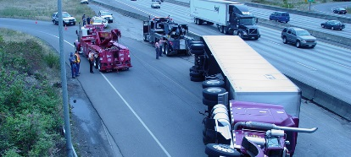
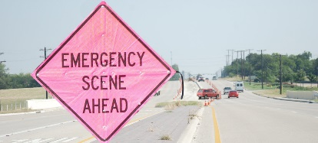
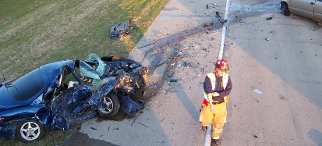
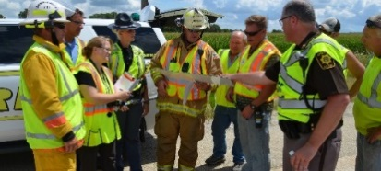
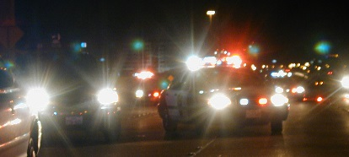
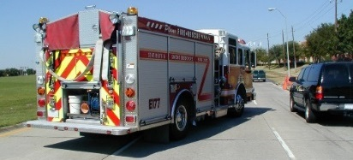
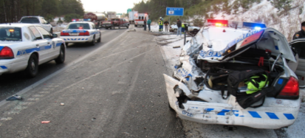
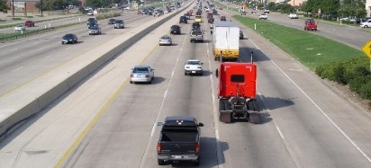

Responder Training Course Announcement
The National TIM Responder Training Program was developed by responders for responders, and was designed to promote consistent training of all responders to achieve the three objectives of the TIM National Unified Goal (NUG):
- Responder Safety
- Safe, Quick Clearance
- Prompt, Reliable, Interoperable Communications
The target audience for this course is all TIM disciplines, including: Communications, Emergency Management, Emergency Medical Services (EMS), Fire/Rescue, Law Enforcement, Towing and Recovery, and Transportation/Public Works.
TIM Responder Training Course Lesson Summary
- Introduction: TIM training program purpose, the dangers encountered by emergency responders working in or near traffic, and the definition of TIM
- TIM Fundamentals and Terminology: safe, quick clearance definition, supporting legislation, and common response terminology
- Notification and Scene Size-Up: roles and responsibilities of public safety communications centers and transportation management centers, and scene size-up reporting
- Safe Vehicle Positioning: safe-positioning of vehicles and blocking
- Scene Safety: emergency vehicle markings, emergency-vehicle lighting, use of high-visibility safety apparel, and safe practices for avoiding the Zero Buffer
- Command Responsibilities: Incident Command System as it relates to TIM
- Traffic Management: components of a Traffic Incident Management Area and the proper use of temporary traffic control devices
- Special Circumstances: incidents involving vehicle fires, hazardous materials, vehicle fluid spills, and crash investigations
- Clearance and Termination: quick clearance strategies, towing and recovery communications, and incident termination

This training has been endorsed by the following national associations: American Association of State Highway and Transportation Officials (AASHTO), American Public Works Association (APWA), Cumberland Valley Volunteer Firemen's Association (CVVFA), Division of State Associations of Chiefs of Police (SACOP), Institute of Transportation Engineers (ITE), Intelligent Transportation Society (ITS) of America, International Association of Chiefs of Police (IACP), International Association of Directors of Law Enforcement Standards and Training (IADLEST), International Association of Fire Chiefs (IAFC), International Association of Fire Fighters (IAFF), International Municipal Signal Association (IMSA), National Association of State EMS Officials (NASEMSO), National EMS Management Association (NEMSMA), National Sheriffs' Association (NSA), National Volunteer Fire Council (NVFC), Towing and Recovery Association of America (TRAA), and Transportation Research Board (TRB).
Details for the upcoming TIM Responder Training course are as follows:
Date: xx
Time: xx
Location: xx
Address: xx
Registration: xx
Contact: xx

